**Instruction**

Here is the start screen of the program.

1. To select a file for processing, click browse input file.

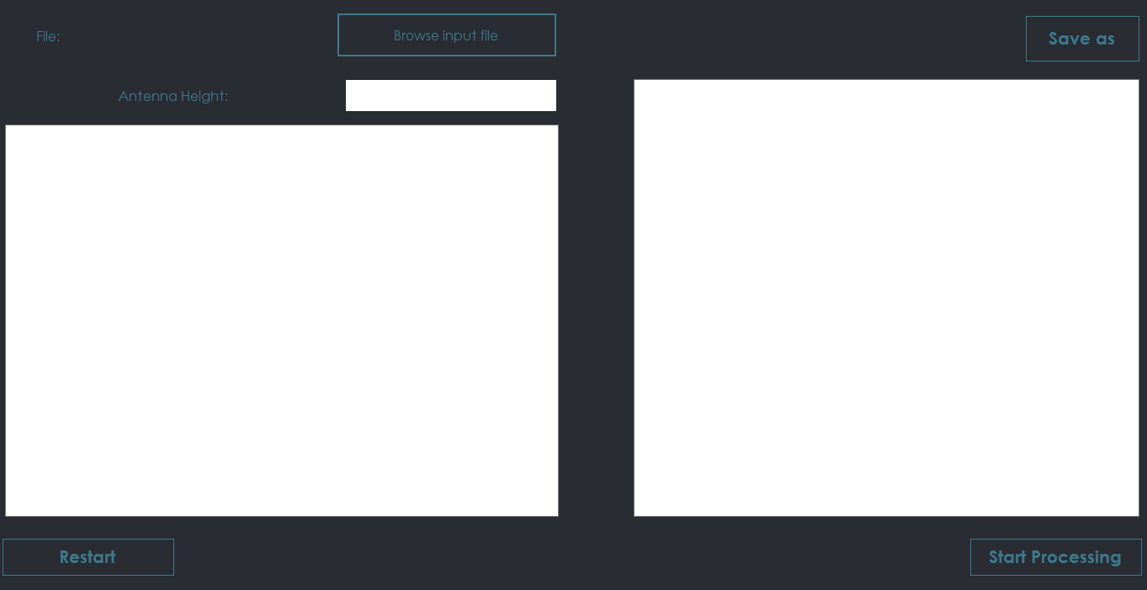

1. 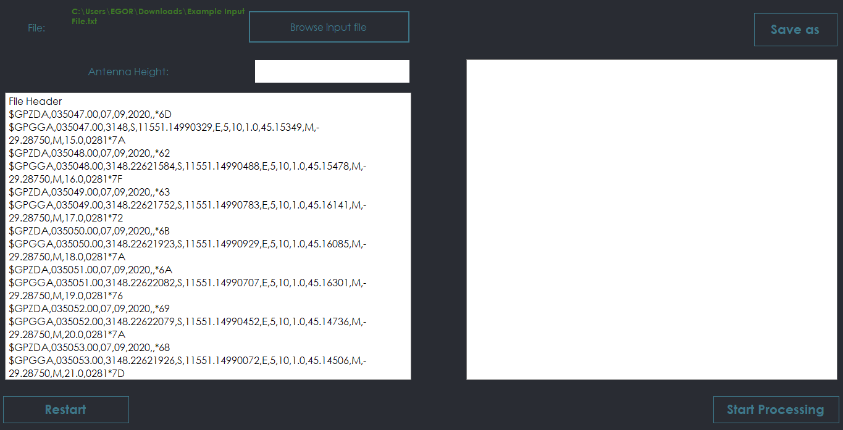In the field “File:” the address of the selected file will appear, and in the field below its contents will displayed
2. 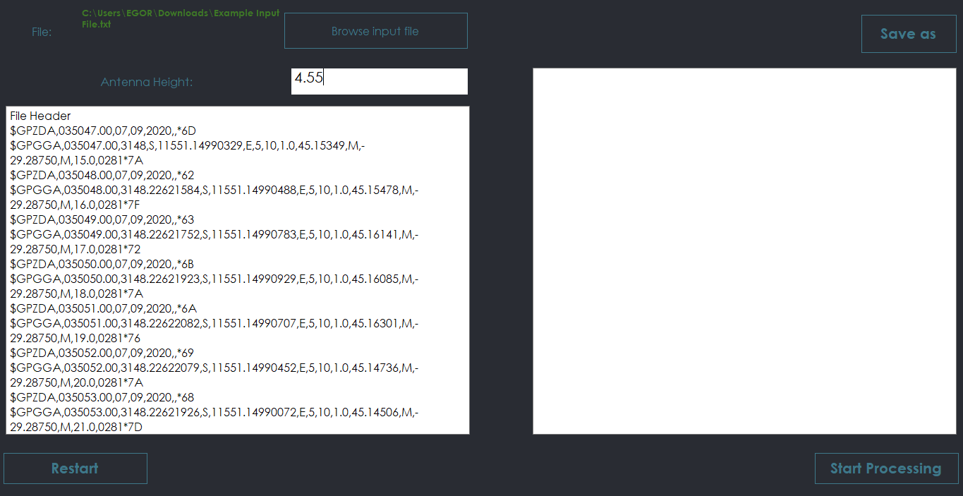Then you’ll need to input the value of antenna height to start processing.
3. 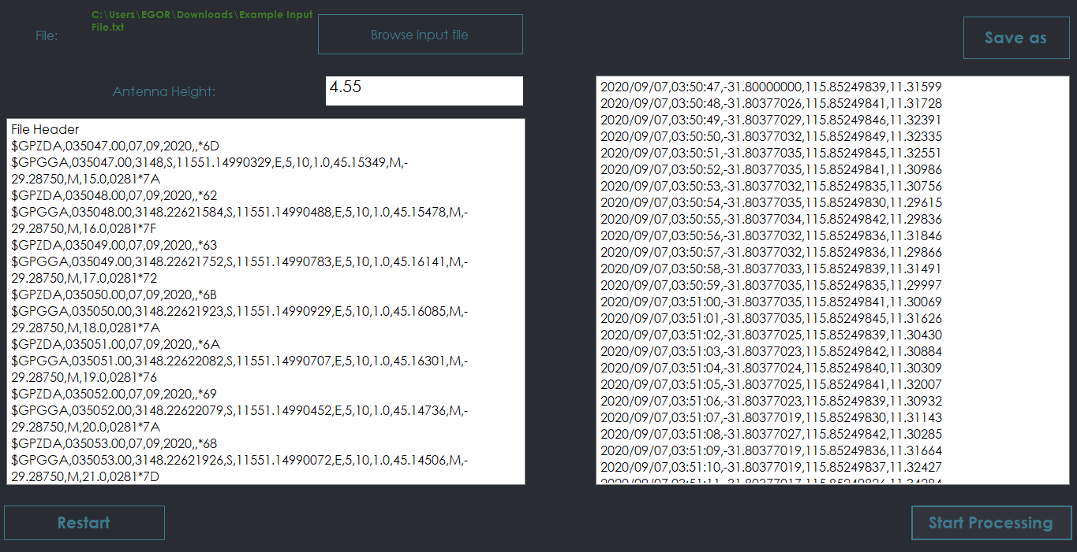The content of the output file will appear in the window on the right side.
4. You can save this file by clicking “Save as” and choose the disk space.

**Notes**

1. The windows with content of input and output files only for read, you can’t correct something inside.
2. Button Restart clear all fields, so you can start with other data once again
3. Program accept only .txt input file format (I can change it if you’ll need)